NAME____________________________LAB MEETING DAY/TIME______________

Lab 6: Evolution

In this lab you will investigate evidence of evolution (Exercise 9), especially vestigial and homologous structures. Then, you will complete an activity NOT in your lab manual, examining the evolution of lizards by examining their characteristics and DNA evidence.

# **Exercise 9, Part A**

**Question 1: Record the correct order of the structures, from oldest to youngest.**

# **Exercise 9, Part B**

**Question 1: Label as many homologous human bones on the diagram as you can identify.**

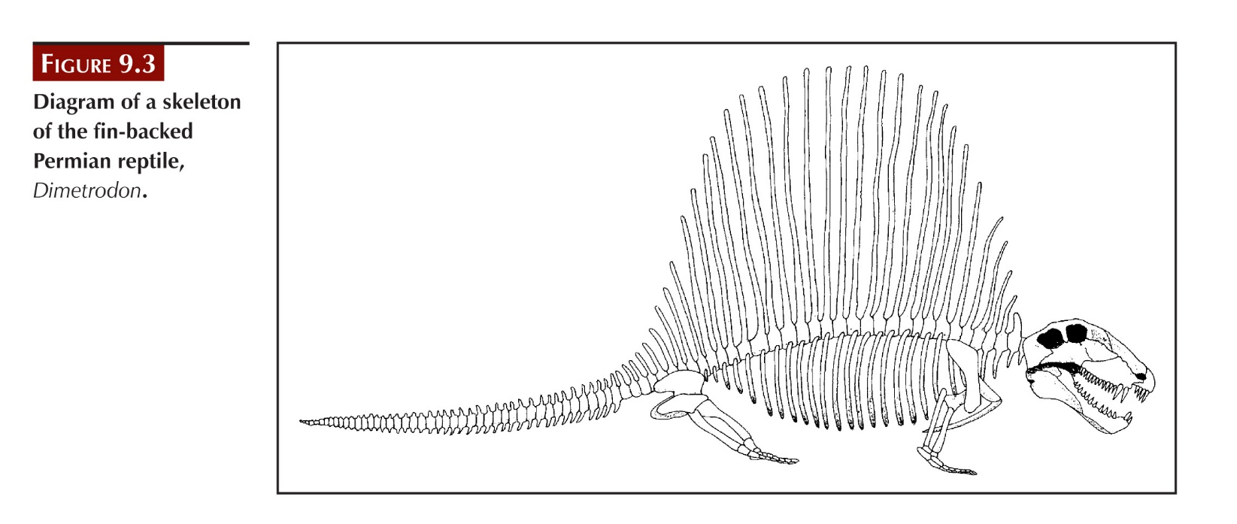

**Question 2: Follow the directions to color the homologous bones below. If you use different colors than indicated in the directions, include a legend below the figure.**

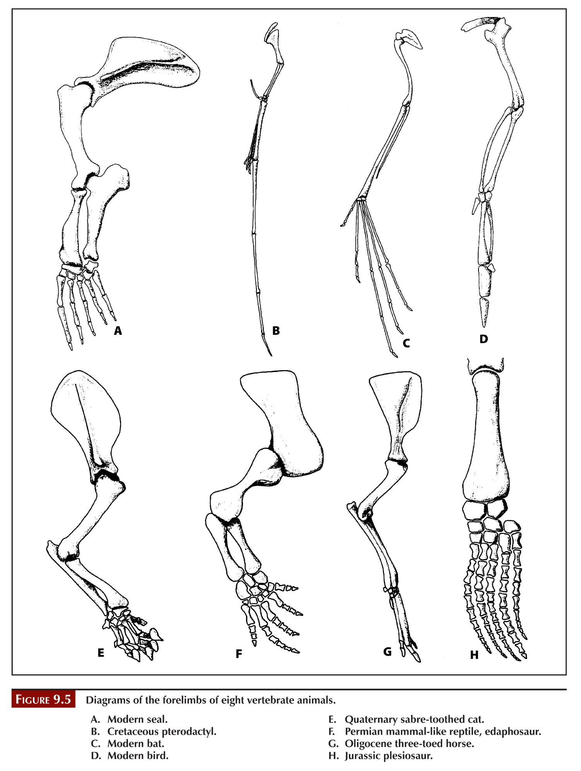

**Question 3: Summarize here:**

# Lab 6 Additional Exercise: Evolution of Anolis Lizards in the Greater Antilles

**You will work in groups of 3-4 on this lab – your instructor will hand out the instructions and materials once you have formed your groups. You will record answers here for grading, but need to refer to the exercise handouts to know what questions to answer.**

**Part I, Question 1**

**Part I, Question 2**

**Part II, Question 3**

**Part II, Question 4**

**Part II, Question 5**

**Part II, Question 7**

**Part II, Question 8**

**Part II, Question 9**

**Part III, Question 10**

**Part III, Question 11**

**Part III, Question 12**

**Part III, Question 14**

**Part III, Question 15**